1. File -> New Project
2. Select Project...
3. Select Android Project and click Next

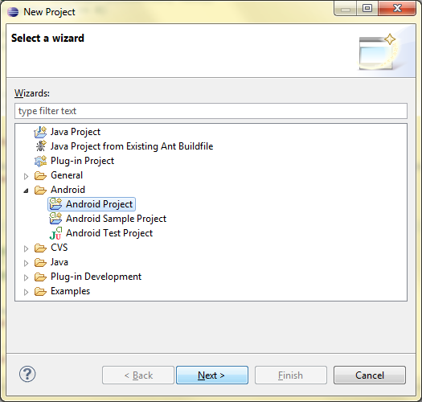

1. Type in the Android project name and click Next

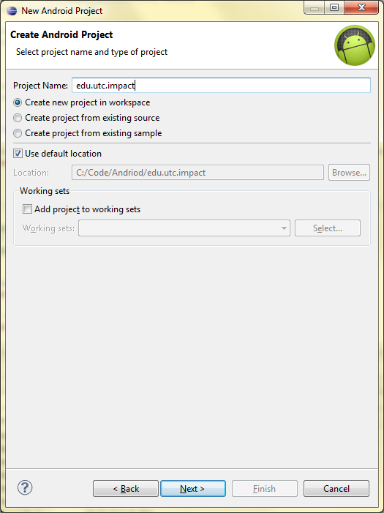

1. Select the desired minimum SDK to build to and click Next.